Navigation:
Code:
import React from 'react';
import { Navbar, Nav, Container, Button } from 'react-bootstrap';
import { Link, useNavigate } from 'react-router-dom';
import { useAuth } from '../contexts/AuthContext';

function Navigation() {
const { currentUser, logout } = useAuth();
const navigate = useNavigate();

const handleLogout = () => {
logout();
navigate('/');
};

return (
<Navbar bg="dark" variant="dark" expand="lg">
<Container>
<Navbar.Brand as={Link} to="/">React App</Navbar.Brand>
<Navbar.Toggle aria-controls="basic-navbar-nav" />
<Navbar.Collapse id="basic-navbar-nav">
<Nav className="me-auto">
<Nav.Link as={Link} to="/">Home</Nav.Link>
<Nav.Link as={Link} to="/about">About</Nav.Link>
{currentUser && <Nav.Link as={Link} to="/posts">Post</Nav.Link>}
</Nav>
<Nav>
{currentUser ? (
<>
<Navbar.Text className="me-2">
Xin chào, <strong>{currentUser.username}</strong>
</Navbar.Text>
<Button variant="outline-light" onClick={handleLogout}>
Đăng xuất
</Button>
</>
) : (
<Button as={Link} to="/login" variant="outline-light">
Đăng nhập
</Button>
)}
</Nav>
</Navbar.Collapse>
</Container>
</Navbar>
);
}

export default Navigation;

Result:
- Not logged

- Logged

Login Page:
Code:
import React, { useState, useEffect } from 'react';
import { Form, Button, Container, Card, Alert, Spinner } from 'react-bootstrap';
import { useAuth } from '../contexts/AuthContext';
import { useNavigate } from 'react-router-dom';

const Login = () => {
const [username, setUsername] = useState('');
const [password, setPassword] = useState('');
const [error, setError] = useState('');
const [isSubmitting, setIsSubmitting] = useState(false);
const { login, loading } = useAuth();
const navigate = useNavigate();

// Redirect if already logged in
useEffect(() => {
const user = JSON.parse(localStorage.getItem('user'));
if (user) {
navigate('/posts');
}
}, [navigate]);

const handleSubmit = async (e) => {
e.preventDefault();
setError('');

if (!username || !password) {
setError('Vui lòng nhập đầy đủ tên đăng nhập và mật khẩu');
return;
}

setIsSubmitting(true);

try {
const success = await login(username, password);
if (success) {
// Redirect to posts page on successful login
navigate('/posts');
} else {
setError('Tên đăng nhập hoặc mật khẩu không chính xác');
}
} catch (error) {
setError('Có lỗi xảy ra khi đăng nhập. Vui lòng thử lại sau.');
console.error('Login error:', error);
} finally {
setIsSubmitting(false);
}
};

return (
<Container className="d-flex align-items-center justify-content-center" style={{ minHeight: '80vh' }}>
<Card className="w-100" style={{ maxWidth: '400px' }}>
<Card.Body>
<h2 className="text-center mb-4">Đăng nhập</h2>
{error && <Alert variant="danger">{error}</Alert>}
<Form onSubmit={handleSubmit}>
<Form.Group className="mb-3" controlId="formBasicEmail">
<Form.Label>Username</Form.Label>
<Form.Control
type="text"
placeholder="Nhập tên đăng nhập"
value={username}
onChange={(e) => setUsername(e.target.value)}
disabled={isSubmitting || loading}
required
/>
</Form.Group>

<Form.Group className="mb-3" controlId="formBasicPassword">
<Form.Label>Mật khẩu</Form.Label>
<Form.Control
type="password"
placeholder="Nhập mật khẩu"
value={password}
onChange={(e) => setPassword(e.target.value)}
disabled={isSubmitting || loading}
required
/>
</Form.Group>

<Button
variant="primary"
type="submit"
className="w-100"
disabled={isSubmitting || loading}
>
{isSubmitting || loading ? (
<>
<Spinner
as="span"
animation="border"
size="sm"
role="status"
aria-hidden="true"
className="me-2"
/>
Đang xử lý...
</>
) : (
'Đăng nhập'
)}
</Button>
</Form>
</Card.Body>
</Card>
</Container>
);
};

export default Login;

Result:
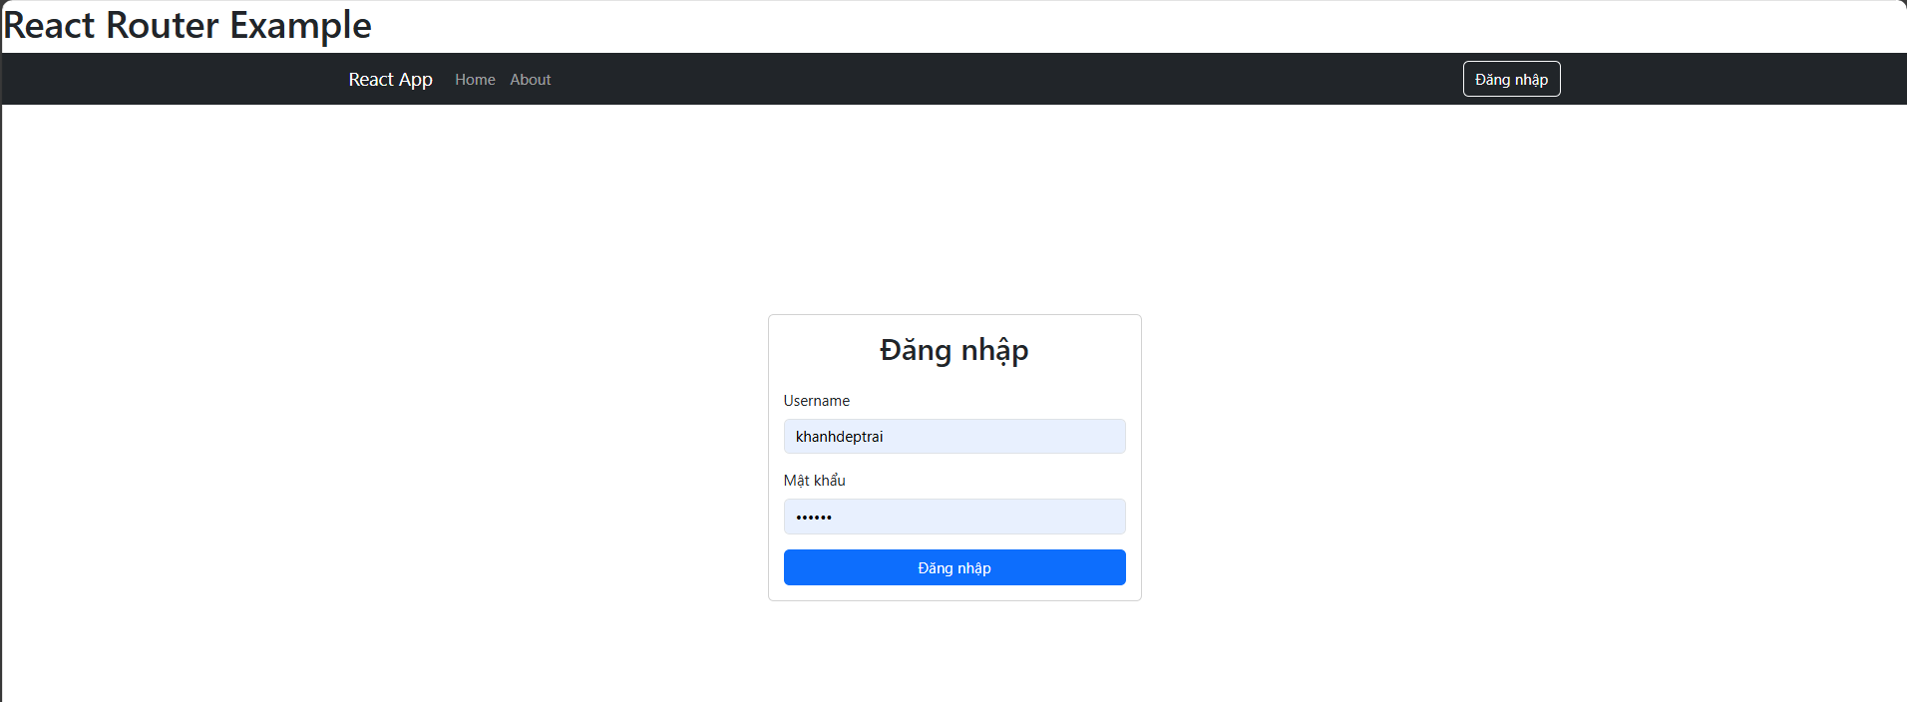

Home Page:
Code:
import React from 'react';

function Home() {
return <h1>Home Page</h1>;
}

export default Home;

Result:
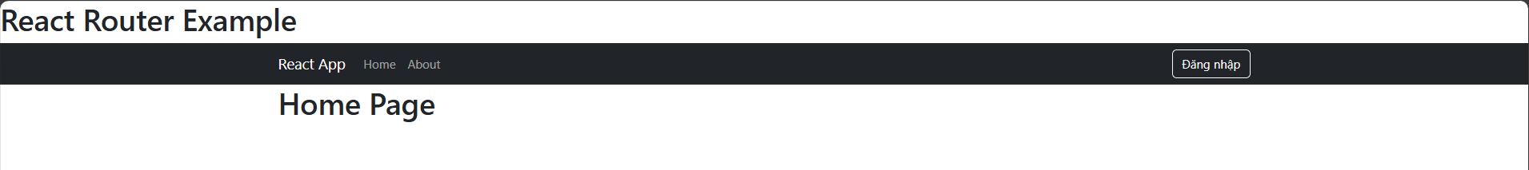

About Page:
Code:
import React from 'react';

function About() {
return <h1>About Page</h1>;
}

export default About;

Result:
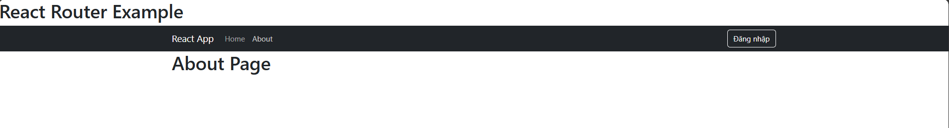

Post Page:
Code:
import React, { useState, useEffect } from 'react';
import { Link } from 'react-router-dom';

function Post() {
const [posts, setPosts] = useState([]);

useEffect(() => {
fetch('/posts.json')
.then((response) => {
// Kiểm tra nếu phản hồi không hợp lệ (status khác 200)
if (!response.ok) {
throw new Error('Network response was not ok');
}
return response.json();
})
.then((data) => setPosts(data))
.catch((error) => {
console.error('Error loading posts:', error);
// Bạn có thể hiển thị lỗi cho người dùng nếu muốn
});
}, []);

return (
<div>
<h2>Post List</h2>
<ul>
{posts.map(post => (
<li key={post.id}>
<Link to={`/post/${post.id}`}>{post.title}</Link>
</li>
))}
</ul>
</div>
);
}

export default Post;

Result:
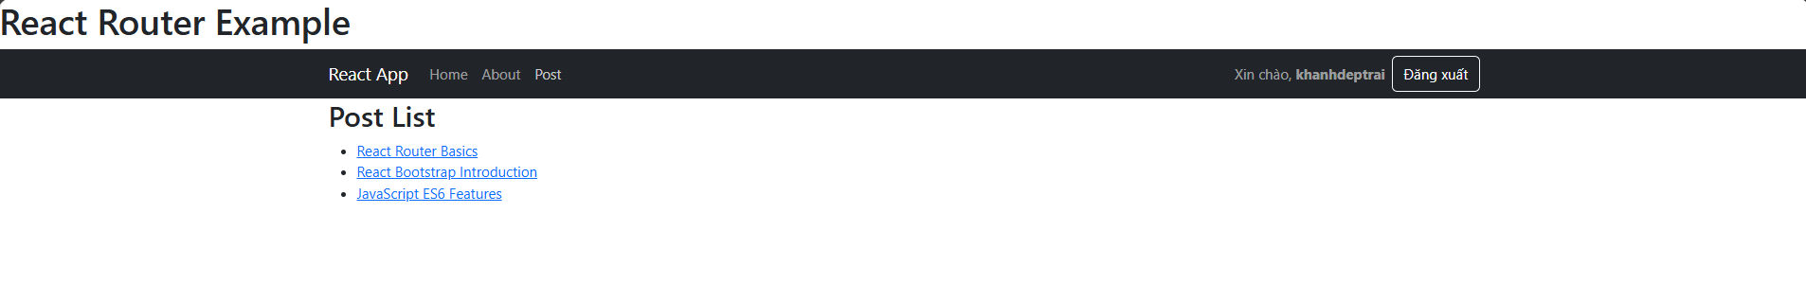
Post Details:
Code:
import React, { useState, useEffect } from 'react';
import { useParams } from 'react-router-dom';

function PostDetail() {
const { id } = useParams(); // Lấy tham số ID từ URL
const [post, setPost] = useState(null);

useEffect(() => {
// Fetch dữ liệu từ file posts.json trong thư mục public
fetch('/posts.json')
.then((response) => response.json())
.then((data) => {
// Tìm bài viết theo ID
const foundPost = data.find(p => p.id === id);
setPost(foundPost);
})
.catch((error) => console.error('Error loading post:', error));
}, [id]); // Mỗi khi ID thay đổi, gọi lại API

if (!post) {
return <h2>Post not found</h2>;
}

return (
<div>
<h2>{post.title}</h2>
<p>{post.content}</p>
</div>
);
}

export default PostDetail;

Result:
- id1:
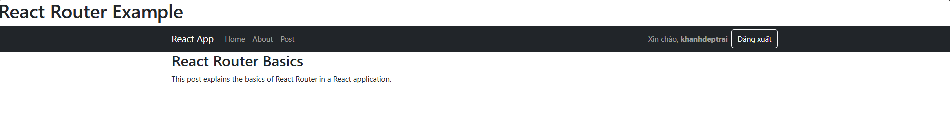

-id 2:
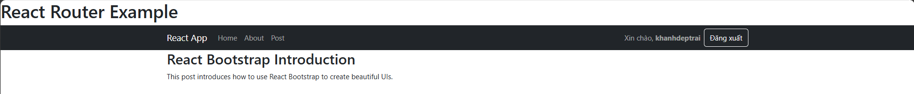
-id 3:
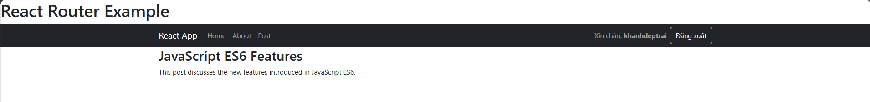

AuthContext,jsx:
Code:
import React, { createContext, useContext, useState, useEffect } from 'react';
import { useNavigate } from 'react-router-dom';

export const AuthContext = createContext();

export function useAuth() {
return useContext(AuthContext);
}

export function AuthProvider({ children }) {
const [currentUser, setCurrentUser] = useState(null);
const [authData, setAuthData] = useState(null);
const navigate = useNavigate();

// Load auth data from auth.json
useEffect(() => {
const loadAuthData = async () => {
try {
const response = await fetch('/auth.json');
const data = await response.json();
setAuthData(data);

// Check if user is logged in on initial load
const savedUser = JSON.parse(localStorage.getItem('auth'));
if (savedUser) {
// Verify the saved user still exists in auth data
const userExists = data.users.some(u => u.username === savedUser.username);
if (userExists) {
setCurrentUser(savedUser);
} else {
localStorage.removeItem('auth');
}
}
} catch (error) {
console.error('Error loading auth data:', error);
}
};

loadAuthData();
}, []);

const login = (username, password) => {
return new Promise((resolve) => {
if (!authData) {
resolve(false);
return;
}

// Find user in auth data
const user = authData.users.find(
u => u.username === username && u.password === password
);

if (user) {
const userData = {
id: user.id,
username: user.username,
};

localStorage.setItem('auth', JSON.stringify(userData));
setCurrentUser(userData);
resolve(true);
} else {
resolve(false);
}
});
};

const logout = () => {
localStorage.removeItem('auth');
setCurrentUser(null);
navigate('/login');
};

const value = {
currentUser,
login,
logout,
};

return (
<AuthContext.Provider value={value}>
{children}
</AuthContext.Provider>
);
}

ProtectedRoute.jsx:
Code:
import React from 'react';
import { Navigate } from 'react-router-dom';
import { useAuth } from '../contexts/AuthContext';

export default function ProtectedRoute({ children }) {
const { currentUser } = useAuth();

if (!currentUser) {
// User not authenticated, redirect to login
return <Navigate to="/login" replace />;
}

return children;
}

App.jsx:
Code:
import React from 'react';
import { Routes, Route, Navigate } from 'react-router-dom';
import { Container } from 'react-bootstrap';
import { AuthProvider, useAuth } from './contexts/AuthContext';
import Navigation from './components/Navigation';
import Home from './components/Home';
import About from './components/About';
import Post from './components/Post';
import PostDetail from './components/PostDetail';
import Login from './components/Login';
import ProtectedRoute from './components/ProtectedRoute';

function AppContent() {
const { user } = useAuth();

return (
<div>
<h1>React Router Example</h1>
<Navigation />
<Container>
<Routes>
<Route path="/" element={<Home />} />
<Route path="/about" element={<About />} />
<Route path="/login" element={user ? <Navigate to="/posts" /> : <Login />} />
<Route
path="/posts"
element={
<ProtectedRoute>
<Post />
</ProtectedRoute>
}
/>
<Route
path="/post/:id"
element={
<ProtectedRoute>
<PostDetail />
</ProtectedRoute>
}
/>
</Routes>
</Container>
</div>
);
}

function App() {
return (
<AuthProvider>
<AppContent />
</AuthProvider>
);
}

export default App;

